**General Guilde lines for preparation of Project Report of MCA 4th Semester**

1. The font of the text in the entire Project Report must be “**Times New Roman**”.
2. Line space – **1.5**
3. The size of the font must be as follows
   1. Chapter Heading – Font Size -14 (**ALL CAPITAL LETTERS AND BOLD**)
   2. Paragraph Heading – Font Size – 13(**Bold**)
   3. Paragraph – Font Size 12

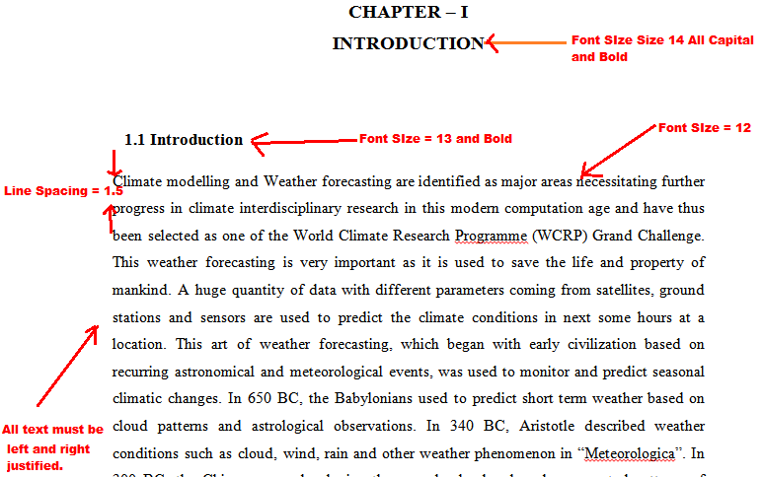

1. The CD/DVD to be submitted by each student must contain the items in organized manner as mentioned below.

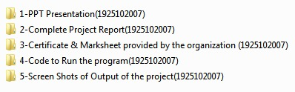

1. All above 5 folders must be kept in a folder named as your Registration Number and Name as shown below.

